Nabeel Ahmed
D207 Performance Assessment
12/31/2024

- Real World Situation:
  - Does the average monthly charge differ from customers who churn and those who do not?
For this, I will use t-test. Average Monthly Charge is the continuous dependent variable and will be tested with the two groups of those who churn and those who do not.
  - Stakeholders can benefit by knowing if pricing is the reason for high churn rates. By knowing this they can adjust their plans accordingly to fit to their customers.
  - The datasets that are relevant are “MonthlyCharge” and “Churn”.
- Analysis of Data:
  - I am using t-test to analyze the data and here is the code:
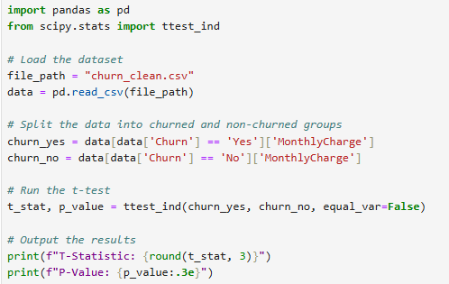
  - Output:
T-Statistic: 39.288
P-Value: 1.782e-290
  - I used t-test since we are comparing means of two groups. First one being,
‘MonthlyCharge’ and the second ‘Churn’. MonthlyCharge will be our continuous dependent variable and Churn will be the independent binary variable. These
variables perfectly match up for us to use t-test.
- Univariate Statistics:
  - This histogram below shows MonthlyCharge and amount of users as frequency,
which is continuous
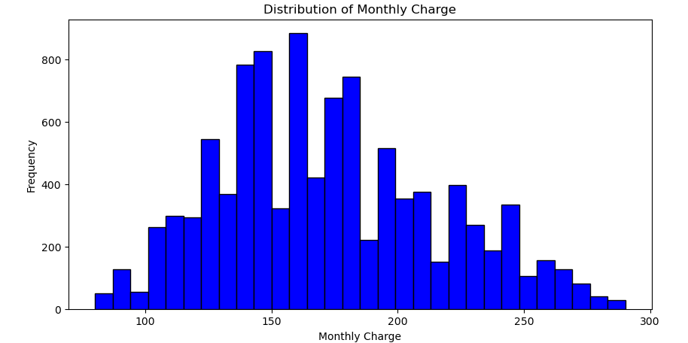
This histogram below shows Tenure (Months) and amount of users as frequency,
which is continuous
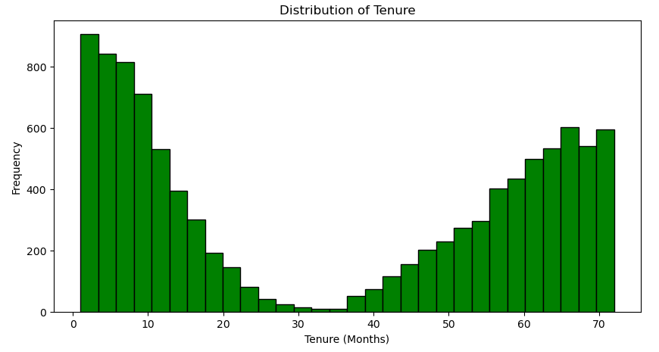
This bar graph below shows Churn rate and amount of users, which is categorical
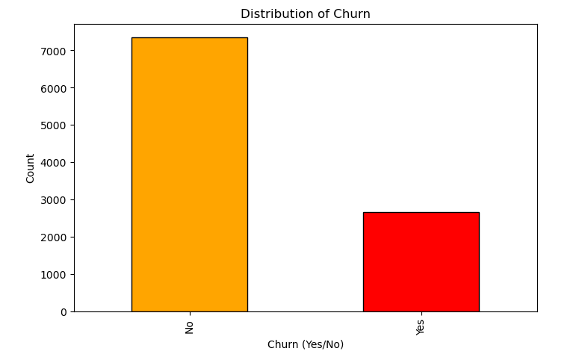
This bar graph below shows Internet service type and amount of users, which is
categorical
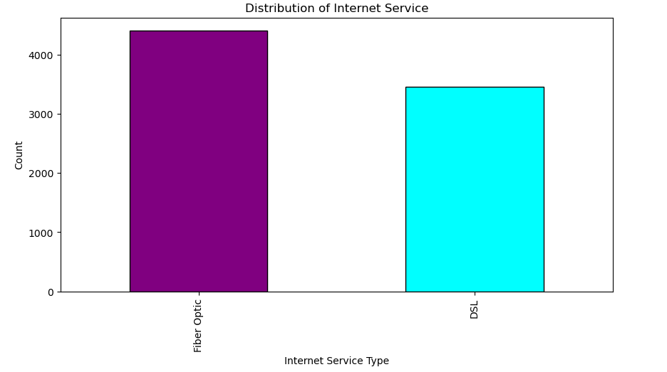
- Bivariate Graphs
  - The scatter plot below shows Tenure v. MonthlyCharge for users, which is
continuous v. continuous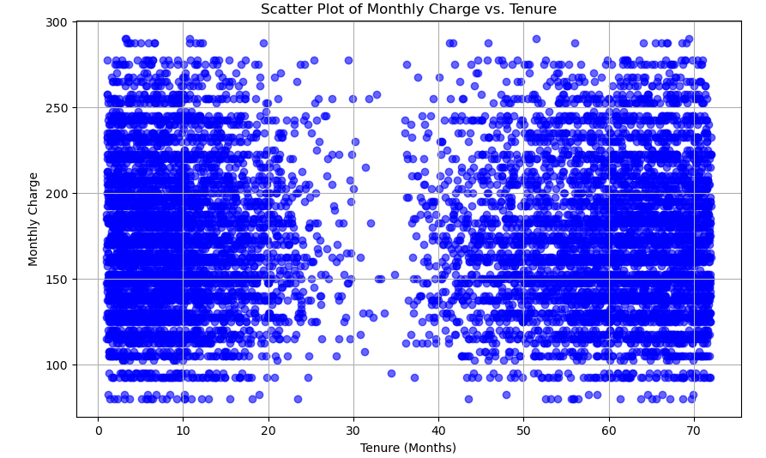
The Box plot below shows MonthlyCharge by Churn rate, which is categorical v. continuous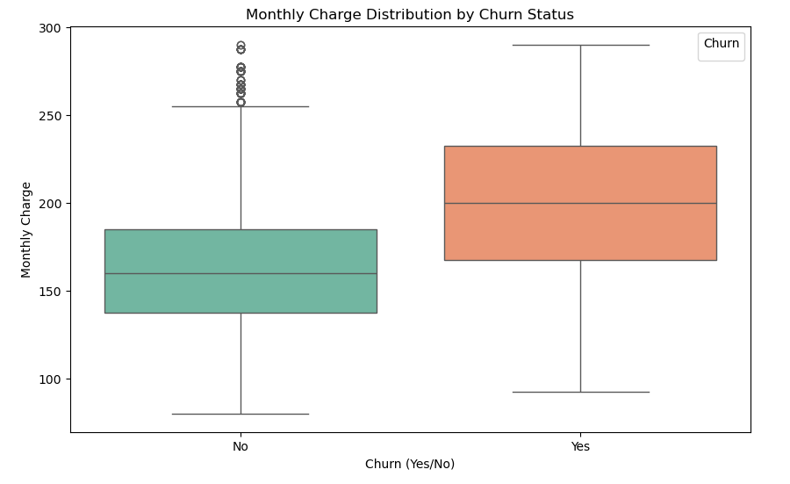
The Bar graph below shows Churn by Internet service used, which is categorical v continuous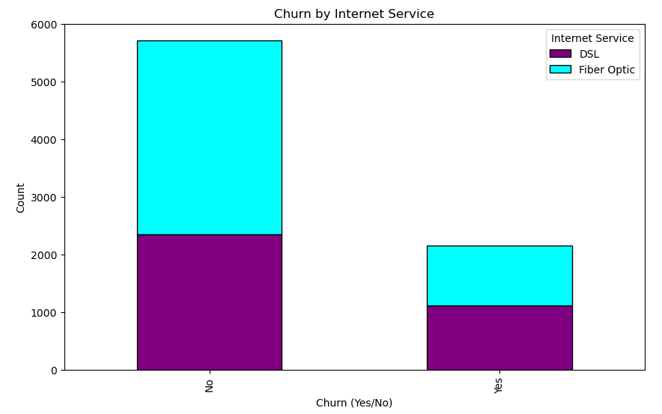
- Implications of Data
  - The results of the t-tests were:
T-Statistic: 39.288
P-Value: 1.782e-290
This shows that we can reject the null hypothesis since the p-value is very close to 0.
We could say as a result that customers who churn have significantly different
monthly charges than customers who do not churn, most likely a higher monthly
charge, as we can see in the box plot above, “Monthly Charge Distribution by
Churn Status”
  - The dataset shows very specific points and there could be external factors that are not displayed that could affect customer churn rate.
Another issue is that, this test does not define causation, we have a correlation
between churn rate and monthly charge, yet the causation can not be detailed
specifically from the limited dataset given.
  - Course of action to take would be to target the highly charged customers and find ways to retain their business, be more interactive with them, whether that be
surveys for them to provide feedback or other services to retain them. Surveys
would be an optimal way to find dissatisfied customers and quickly making it
right by offering incentives to retain their business. Find out if monthly charge is
the factor that is driving them away and if so, then make it right with them
- https://wgu.hosted.panopto.com/Panopto/Pages/Sessions/List.aspx#folderID=%2237a1d719-eece-4cea-949f-ac7201896b42%22&folderQuery=%22d207%22
- Sources:
Alexander. (2024, January 20). Univariate Analysis: Definition, examples. Statistics How To. https://www.statisticshowto.com/univariate/
GeeksforGeeks. (2024, May 20). Bivariate Analysis. https://www.geeksforgeeks.org/bivariate-analysis/
How to do a T-test in python?. The Data Scientist. (2024, April 26). https://thedatascientist.com/how-to-do-a-t-test-in-python/

